Mano River Union Ecosystem Conservation and International Water Resource Management Project (IWRM)
Second Quarter Report
Reporting Period: April-June, 2019
Prepared by: Daoda S. Carlon: Technical Assistant
7/1/2019

To : Abdoulaye Doumbia
MRU Regional Project Coordinator
Freetown, Sierra Leone
By : William B. Pewu
National Project Coordinator
Forestry Development Authority
Monrovia, Liberia

Table of Content
- Introduction
- Executive Summary of Results Achieved
- List of Planned Activities During the Period
- Progress
- Knowledge products
- Major communication activities
- Planned activities for the next quarter

Introduction
The MRU IWRM project was launched in Liberia on April 2-3, 2018 in order to give implementing partners the insight into the implementation of the project, its objectives, and how to foster the smooth operation of the project in Liberia and the MRU basin at large.
However, the implementation of the project took a slow pace as a result of the transition which witnessed the coming in of a new government. Agreements previously reached by the outgoing administration had to be assessed and verified.
Amidst these constraints, the FDA has made some gains in the recruitment of one Senior and three Junior Technical Officers and the selection of additional consultants in the implementation of the ROAM program. The FDA has also made some positive strides in winning the interest of implementing partners who have shown their willingness to participate in the implementation of the project.
Executive summary
The Mano River Union (MRU) comprises of four (4) member countries (Liberia, Sierra Leone, Guinea, and Cote D’Ivoire) in West Africa that share borders in the Upper Guinea Forest and ten (10) transboundary river basins within the Economic Community of West African States (ECOWAS). The four (4) countries of the MRU received a Global Environmental Facility (GEF) grant of USD $ 6,970,000.00 for the implementation of a regional project named “ECOSYSTEM CONSERVATION AND INTERNATION WATER RESOURCE MANAGEMENT PROJECT” through the IUCN and PACO. The project was validated by the GEF Secretariat in December 2016 and approved in February 2017 by IUCN.
Since the beginning of 2019 and up to present, the FDA/NEA has worked with partners to implement the MRU/GEF IWRM project.
List of activities during the period under review
The FDA/NEA During the quarterly period (April-June, 2019) under review, has participated in a number of activities including:
- The successfully validated and legalized the TORs of three landscapes (Gola, Wonegizi, and ENNR) and the TOR of the MTC as well.
- Validated, with the help of MTC, and submitted activities 2.4 & 2.5 to the REA for consideration
- Published one EOI Activity: 2.13
- Published One EOI consultancy services to audit the project financial statements
- Procured insurance for four motorcycles
- Assigned two Junior Technical Assistants in Wonegizi and ENNR
- Erected billboards in three landscapes (Gola, ENNR, & Wonegizi)
- Completed the procurement of ICT equipment (1 printer, 6 laptops, & 5 digital cameras)
- Held two follow-up zoom teleconference meeting with IUCN, REA and all NEAs on ROAM progress in May
- ROAM Activities 1.2, 1.9, 1.14 and 1.17 completed in Wonegizi in May 2019
- One NEA’s update meeting held with REA on updates of Activity: 2.4 & 2.5 and discuss total progress (May 31, 2019).
- Negotiated with Africa Venture for the implementation of Activity: 1.7 to develop Terms of Reference to train strategic organizations on sylvicultural oriented new agricultural measures/approaches and their certification principles

Progress Report
During the period under review, April-June, 2019 the NPCU participated in a number of activities.
The successfully worked with MTC and the consultant to validate workshop of Activities: 2.4 & 2.5 on the baseline studies of TRANSBOUNDARY WATER RESOURCES MANAGEMENT
(MOA-MAKONA AND CAVALLA RIVER BASINS
On June 13, the NEA, NPCU, TA and MTC participated in validate workshop of activities: 2.4 & 2.5 on the baseline studies of transboundary water resources management
(Moa-Makona and Cavalla River basins. About 21 participants from the Multisectoral Steering Committee (MTC) who are also working in relevant government’s ministries and agencies as well and private institutions directly or indirectly related to the water, natural resource, and the environment attended the validation workshop. The ROAM consultants also took advantage of the exercise as an observer.

All of the regional countries and their respective technicians attended, including international consultants from IUCN and consultants who were hired for the ROAM activities.
Objective of the workshop
- Present findings from the Stakeholders consultations and assessment
- Seek peer review through open discussions
- Validate the report

Expected results
- All participants would give the expert opinion
- That document would be validated after inputs are made and accepted
- Policy regarding water resources or water use in Liberia are known
- Other stakeholders are informed of the project
During the validation, it was raised that the consultant makes all necessary corrections and circulate the final document before publication. As a result, the consultant realized that this request was vital to the successful achievement of the process so the time was extended for edits.

- Delivery of three motorcycles and assignment of two JTAs to the landscapes
Also, during the period under review, the NPCU and TA successfully planted three billboards of the project and delivered three motorcycles to three landscapes (Gola, ENNR, and Wonegizi) for the smooth implementation of the project by the Junior Technical Assistants. This means the project’s visibility in the landscapes has increased and physical representation of the project is also being felt by the communities. Local authorities within the different landscapes witnessed the planting of the billboards and commended the idea of the project, especially those in Gola.

Objectives
The objectives of the mission were:
- Provide logistics to project staff
- Create awareness to other development partners operating in the landscapes
- Enhance the smooth implementation of the project on ground
Expected output
At the end of the mission:
- Each JTA received one registered and insured motorcycle, one USB Orange modem, and $20.00 scratch cards, one helmet, and a reflector jacket
- Local law enforcement authorities were informed of the project
- LCC leadership as well as the local authorities received copies of the validated TORs signed by the local authorities and approved by the NEA Managing Director

As part of the next step, the NPCU and the TA have begun plans to conduct an identification mission of riparian communities in order to establish the LCC of the Mao-Makona and Cavalla River Basins, in keeping with Component 2 of the project. Also, the NPCU and the TA will do a follow-up with REA on the adoption of a TOR for Activity 1.7 so that Africa Venture and the NEA can establish an MOU for the implementation of Activity: 1.7. This activity is intended to develop a Term of Reference to train strategic organizations on sylvicultural oriented new agricultural measures/approaches and their certification principles.
The next quarter will also consider the establishment of transboundary platforms in Gola with SL, Wonegizi with Guinea, and one in ENN Cote’d Ivore on ecosystem management as well as the establishment of transboundary platforms in the two water basins.

- Knowledge Product: Barrier Analysis
- low level capacity of most of the national institutions and administrations
- fragmented political will to enhance conservation strategies and management planning schemes within the MRU basin
- Poor information dissemination among development partners
- Access to information in project affected communities
- Lack of communication networks

- Communication Activities
- FDA website has been used for major vacancy announcements, but efforts have been made to create a webpage for the project
- Liberia E-mansion communication portal is also used to make major advertisements

- Planned activities for the next quarter (July-September, 2019)
- Ensure that Gola TOR is signed by the local authorities and the NEA/FDA
- Comprehensive report of the ROAM program (Activities 1.2, 1.9, 1.14, 1.17)
- A Comprehensive report of Activity 2.4/2.5 (Transboundary Diagnostic Analysis {TDA} of the priority transboundary basins of the project.
- Ensure the deployment of Junior Technical Assistants to their respective landscape
- Local knowledge is a good resource to begin with.
Challenges
- Procurement process at NEA
- Procurement budget for Liberia has not been received
- Communication with field staff in the landscapes sometime difficult due to lack of internet

Appendix:
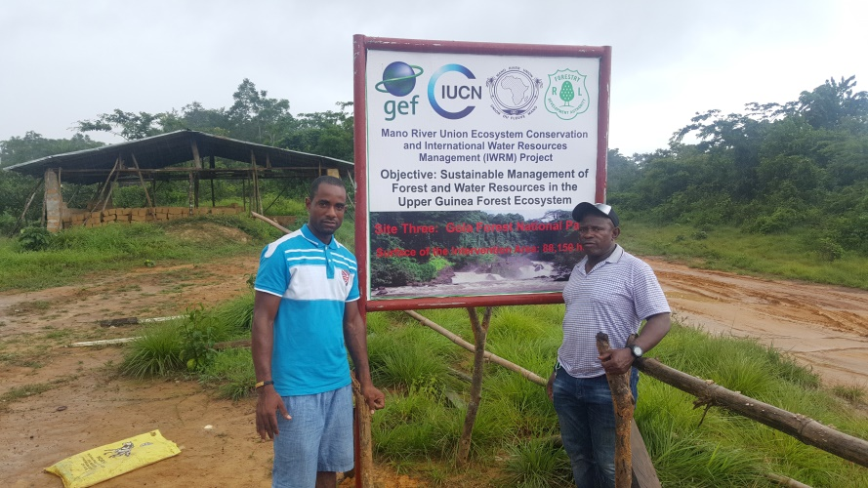
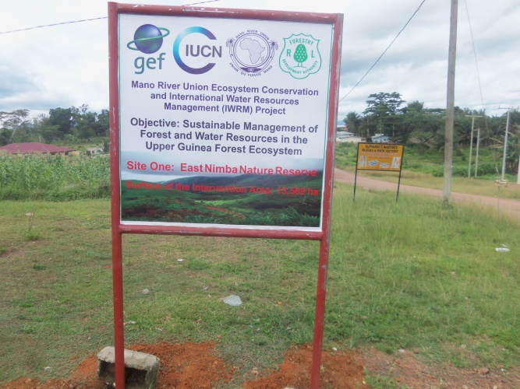
ENNR’s billboards
Planting of Gola’s billboards
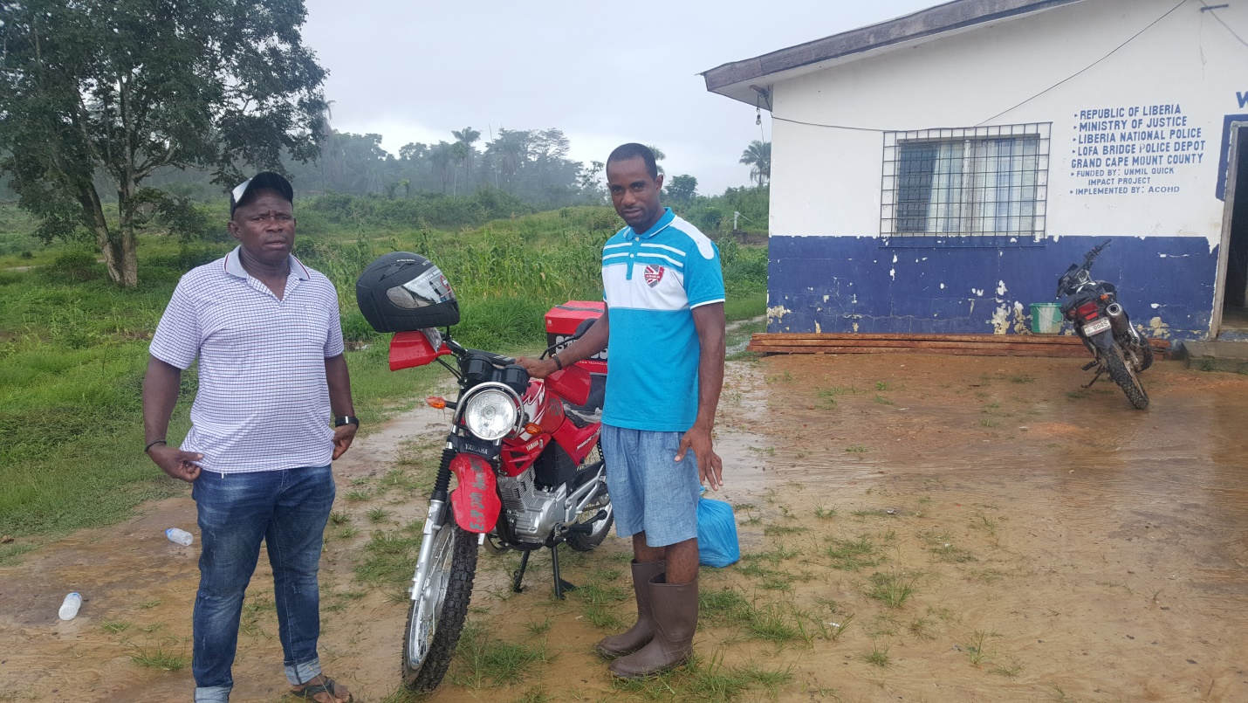

Chief park warden of Gola on the left, TA on the right at Gola Landscape with newly assigned Motorbike

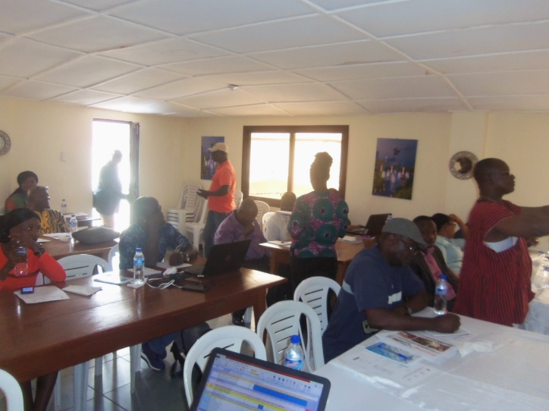
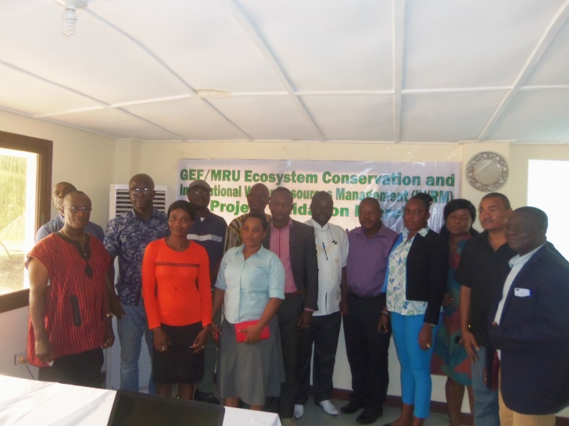

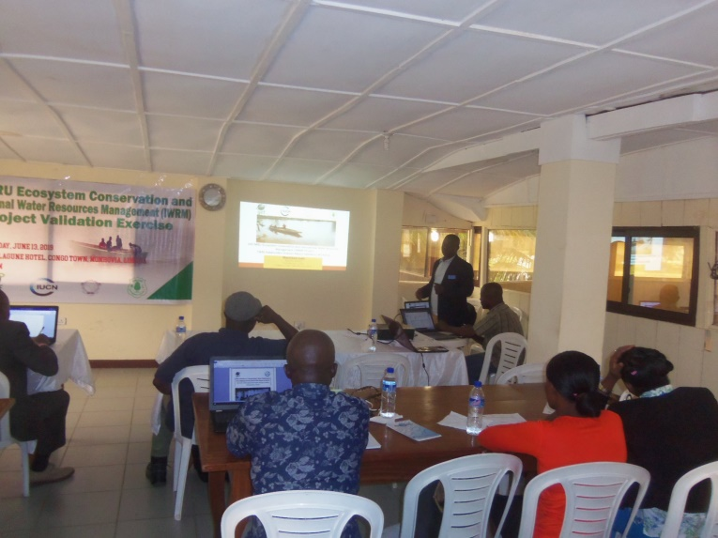
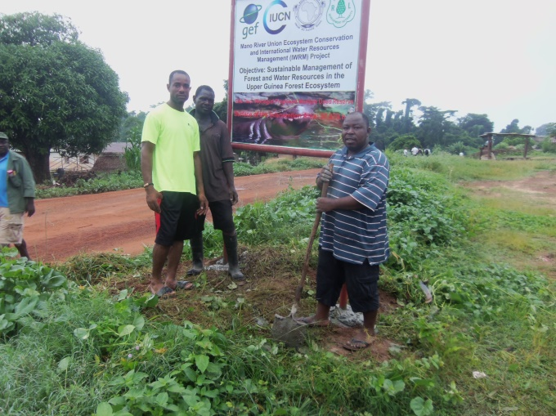
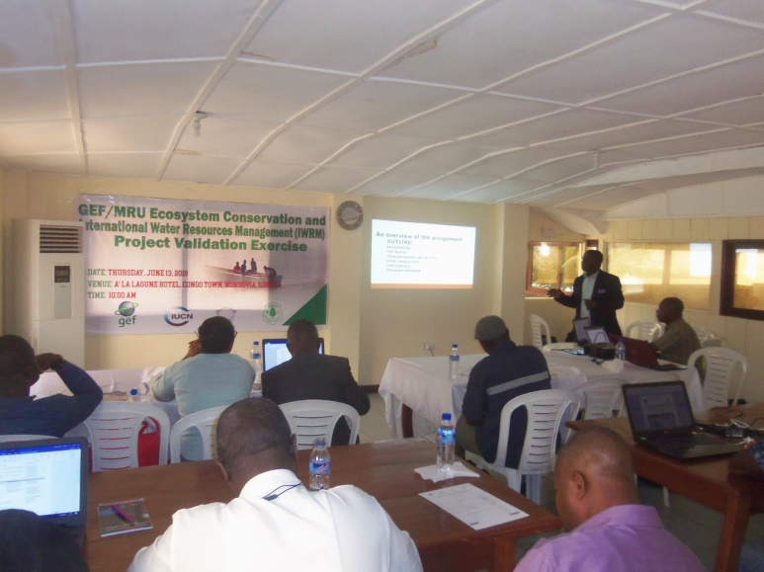
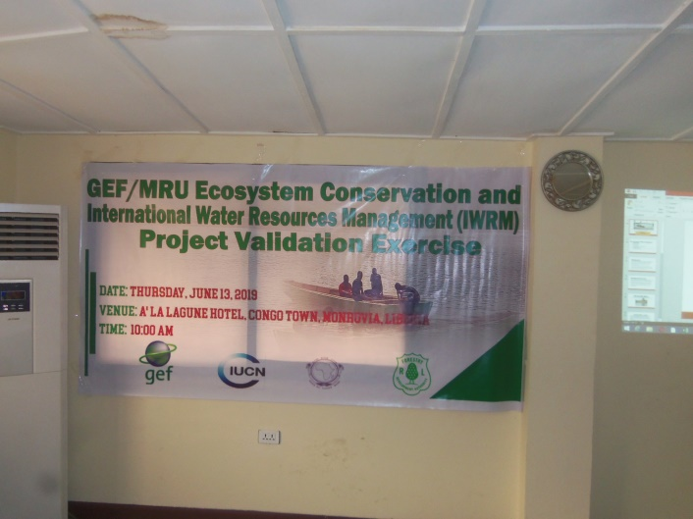
Wonegizi billboard planting, TA in green JTA in blue
Consultant Presenting
Group Photo
Participant in session
Participants taking notes
Poster of the program

