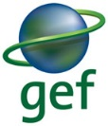
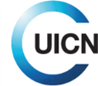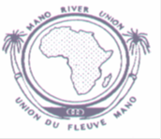
National level Multisectoral Technical Committee workshop

MANO RIVER UNION (MRU) ECOSYSTEM CONSERVATION AND INTERNATIONAL WATER RESOURCE
MANAGEMENT (IWRM) PROJECT

Cross Section of Participants at the national level Multisectoral Technical Committee (MTC)
Launching and Planning Workshop of the IWRM project in Liberia
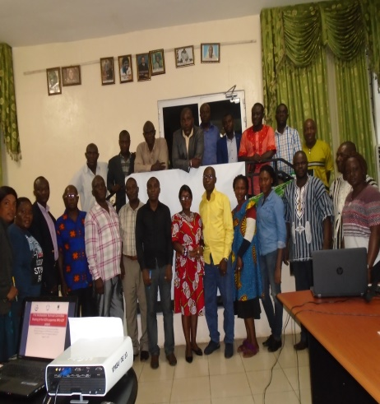
To : Abdoulaye Doumbia
Program Officer/Infrastructure and Water Resources
MRU Secretariat, Freetown Sierra Leone

From: William B. Pewu
National Project Coordinator
MRU-GEF (IWRM) Project

DATE: 31 August 2017
VENUE: Forestry Development Authority
Whein Town, Paynesville, Monrovia

Background
The Mano River Union (MRU) comprises of four (4) member countries (Liberia, Sierra Leone, Guinea, and Cote D’Ivoire) in West Africa. These countries who share borders in the Upper Guinea Forest and ten (10) transboundary river basins that belong to the Economic Community of West African States (ECOWAS) received a Global Environmental Facility (GEF) grant of USD $ 6,970,000.00 for the implementation of a regional project named “ECOSYSTEM CONSERVATION AND INTERNATION WATER RESOURCE MANAGEMENT PROJECT” through the IUCN and PACO. The project was validated by the GEF secretariat in December 2016 and approved in February 2017 by IUCN.
The project aims to strength the management of transboundary natural resources for sustainable ecological benefits and improves livelihoods for adjacent forest communities. The project supports local communities in the development of alternative means for income generation, which will lead to increase forest cover and its associated benefits (ecosystem services, biodiversity, carbon sink, etc.) at local and global levels.
On August 31, 2017, a one day Launching and Planning Workshop of the Multisectoral Technical Committee for the MRU GEF-IUCN funded project was held at the Forestry Development Authority head office board room, Whein Town, Paynesville, Liberia. The workshop was organized to share information on the project to the newly established Multisectoral Technical Committee (MTC) and FDA top management and also to obtain suggestions to foster smooth operation of the project in Liberia and the MRU basins.
The workshop also gave stakeholders the opportunity to get first-hand information about the project scope of operations, sites, aim and objectives, targeted beneficiaries, management structure (National Project Coordination Unit, and Regional Management teams), budget, timeframe, reporting and monitoring and evaluation. The workshop further provided opportunity for the National Executing Agency, known as the Forestry Development Authority (FDA) to officially introduce the project to institutions that will be involved with the daily management of the project for sustainable protection and management of territorial water and forest resources on one hand, and members of the National Project Coordination Unit (NPCU) and National Focal Point (NFP) to acquaint all stakeholders (at National Level) with IUCN procedures for the implementation of the project.
Objectives
The general objective of the national level Multisectoral Technical Committee (MTC) launching and planning pre-financed workshop by the National Executing Agency (FDA) was to formally introduce the Ecosystem Conservation International Water resource Management (IWRM) project being supported by the GEF-IUCN under the auspices of the MRU to the various institutions involved in the management of forest and water resources in Liberia, and to further inform the participants about the expected results of the project implementation, and formally strategize an action plan to be taken in the last six (6) months of year 1 (FY1, July-December, 2017) of the project for its effectiveness.
ARRIVAL AND REGISTRATION OF PARTICIPANTS
The workshop began with the registration of invitees at 9:30am. This was followed by a welcome remark by the National Focal Point (NFP) who thanked the invitees for honoring the invitation by taking up their basic schedules to attend the first session of the MTC workshop.
WELCOME REMARKS
Hon. Darlington S. Tuagben, Managing Director of the Forestry Development Authority (FDA), opened the meeting. He welcomed Multisectoral Steering Committee (SC) members and other participants to the meeting and wished them fruitful deliberations. He informed MTC on the Ecosystem Conservation International Water resource Management (IWRM) Project that is being supported by the GEF-IUCN under the auspices of the MRU to the various institutions involved in the management of forest and water resources is really needed by us. He then briefly talked about the need for, and the importance for building institutional collaboration and synergies between agencies, ministries, and stakeholders for smooth execution of the project especially in Liberia two landscapes (Makona-Moa Basin and Cavala River Basin).
SELF-INTRODUCTION OF PARTICIPANTS
All participants were given equal opportunity to introduce themselves individually. After the self-introductory session, the participants settled down for a group photo (see cover page and annex).
Breakfast
The participants had breakfast at 10:30 and returned to session at 11:00am
TECHNICAL PRESENTATIONS SUMMARY
- Four PowerPoint’s presentations were done during the MTC one-day workshop
(A). Overview of project
Mr. William Pewu, Project Coordinator gave a historical perspective of the MRU’s formation which began on October 3, 1973 and occasioned by the signing of the Union’s declaration (treaty) in Sierra Leone by the Heads of States of Liberia and Sierra Leone for the purpose of economic and regional integration. Mr. Pewu further highlighted how Guinea and Cote d’Ivoire later joined the Union on October 24, 1980 and May 15, 2008 respectively, thus bringing the Union’s membership to a total of four.
The Project Coordinator then presented an overview of the MRU project where he gave a brief description of the project in terms of the background analysis of the project (Baseline course of action), the project profile, project objectives, and the expected global environmental benefits that the project has envisaged. Mr. Pewu also earmarked key activities to be undertaken for the last six months (July-December, 2017) as an annual program that has been planned and validated by the IUCN and MRU.
(B). Project institutional Framework
The National Focal Point (NFP) Mr. Blamah, outlined the institutional structure of the project. He informed the participants that the project will set up a task force/Regional Steering Committee to facilitate the project implementation in the four (4) countries. He further elaborated on the other structural arrangements including the Regional executing Agency, the National executing Agency that supervises the National Project Coordination Unit under the guidance of the National Focal Point. Other structural arrangements include the National Interministerial committee/Multisectoral Technical Committee (MTC), the Site Specific Implementation Partners and the Local Transboundary Committee Moa, Mankona River Basin and the Cavalla River Basin. The National Focal Point (NFP) concluded by outlining the roles and responsibilities of stakeholders under the framework of these institutional arrangements.
(C). Results Framework of the project
Mr. Blamah Goll also vividly explained the project’s intention relative to the four years life span of the MRU IWRM project. He further highlighted the activities of the projects in terms of Components 1 & 2 with respect to Integrated Ecosystem Management and the Sustainable Management of Transboundary Waters respectively, coupled with their associated outcomes and outputs based on the project’s targets.
Lunch
The participants went for lunch at 12:30 mid-day and returned to session at 1pm.

Budget
The Project Accountant, Mrs. Tanneh Harmon, also made a brief presentation regarding the workplan and the budget. She explained that IWRM project is divided into two components: Component 1 is focused on the Integrated Forest Ecosystem, and component 2 is focused on Sustainable Management of Transboundary water. She also explained that the total budget for the project is about 6 million USD over a four-year period (2017-2020) distributed among the four MRU countries.
The Project Account further indicated that to jump start the project, a six-month workplan has been prepared for the remaining 6 (six) months (January-December, 2017) for implementation. The budget for Liberia for the remaining six (6) months is put at $396,736.00.
All presentations were followed by questions and answers period. Afterwards, the participants went into further discussion on project based issues which included:
  - The need to present the Approved Project Proposal document to all MTC members
  - In the future, the MTC workshop draft report should be prepared and circulated for inputs to MTC members and other participants who attended such before finalization and onward submission to the MRU Secretariat also feature progress made by all RF in their respective regions.
  - MTC members commended the NEA for reporting and achievements reached so far under the project implementation schedule during this year. But they requested the NEA to allot more projects activities /programs to effective local institutions and partners for smooth implementation of project activities especially at the national level
  - PC efforts of including CSOs in decision-making processes were recognized. However, evaluation of CSOs impact on the project formulation was thought important. Perhaps MRU could look into institutionalization of M&E procedure to measure CSOs impact.
  - MTC members sought the views of NEA representatives on the budget value added of IWRM Project. They asked whether the IWRM Project budget outlines/stipulated within the project document will be realistic for achieving their objectives at the regional and national levels and if there will be room for increment. The PC indicated no but said that budget is only flexible but cannot increase for now. However, this is a very crucial issue.
  - PC added –valued to the MTC: Forging inter-regional and national partnerships and providing a platform for information and knowledge exchange is one important value added of IWRM Project, which are not quantifiable and difficult to measure their impacts.
Rapporteur
At the end of the workshop, the Secretariat headed by the National Project Coordinator read the minutes of the one-day deliberation. The minutes were accepted and endorsed. Vote of Thanks and closing Remarks were conducted by Mr. Joseph J. Tally, Technical Manager for Commercial Forestry, Forestry Development Authority. Mr. Tally thanked all of the stakeholders for attending the Launching and Planning workshop for the implementation of the IWRM project. He hoped that Liberia will work harder in fostering the objectives of the project.
Prayer
The meeting ended with a prayer.
(e). Payment of Transportation to MTC Members
After the conclusion of the MTC workshop, transportation cost for nine only (9) invited MTC members that attended the meeting was paid. Others participants did not receive transportation allowance due to limited funds used to cover the workshop. Please see annex for a detailed financial breakdown.
CONCLUSION
The National level MTC workshop specifically in Liberia:
- Provided participants with a complete overview of the project and informed them on how the project will be implemented by the MRU States, Communities, and the different partners involved with the project;
- Provided information on the structural implementation arrangement (organic diagram) and results framework of the project;
- Provided information on actions that have already been carried out with regards to project start-up methodology among the four (4) countries,
- Provided details on budget distribution/allocation among the four countries (Liberia, Cote d’Ivoire, Guinea and Sierra Leone) and the workplan to be implemented by MRU member countries based on the allotted budgets,
- Ensured that suggestions are provided by national institutions in order to assist the Project Coordination Unit (PCU) facilitates smooth implementation of the project in order to generate the expected results throughout the project’s life span;
- Assisted the National Executing Agency, (FDA) to plan actions for the last six months of the first year 2017 (FY1);
Results and outputs (Achievements) of the workshop
- Ministries, Departments, Agencies, National and International NGOs that participated in the MTC/national steering committee workshop were informed about the project financing;
- Participants and partners were informed about the institutional arrangement of the project, including the roles and responsibilities of the National Executing Agency/FDA, as well as institutions implementing the project;
- Participants and partners reviewed the remaining six (6) months (July-December, 2017) 1 FY1 activities of the workplan;
- Participants were informed of the project budget and timeline as well as the target beneficiaries
- All participants agreed on the methodology, and result framework, including the remaining six (6) months (July-December, 2017) roadmap, but decided to do a desk study of the project in order to do some adjustment in the timeline considering the overdue signing of the Service Agreement and delay in depositing of funds to the project regional and national accountants .
Participants and stakeholders of the workshop
This MTC/Steering Committee workshop was attended by nine (9) delegates officially representing ministries/agencies/NGOs including the Ministry of Lands, Mines, and Energy (MLME), Environmental Protection Agency (EPA) of Liberia, Ministry of Internal of Affairs (MIA), Ministry of Justice (MOJ), Liberian Maritime Authority (LMA), Liberia Institute of Strategic Geo-information System (LISGIS), Wild Chimpanzee Foundation (WCF), Ministry of Agriculture (MOA) and the University of Liberia (Student Observer) . The lead agency, the Forestry Development Authority (FDA), known as the National Executing Agency (NEA) responsible for the implementation of the project, was represented by eighteen (18) personnel including the Managing Director, four Technical Managers, National Project Coordination Unit (NPCU), the National Focal Point (NFP) and a host of employees amounting to a total of 27 participants. Of this amount there were six (6) females and twenty one (21) males.

Detailed Budget Breakdown
(Table 1)
Detailed budget of the national level Multisectoral Technical Committee (MTC) workshop within the Framework of the GEF ID : 4953, IUCN ID (to be assigned), Full Size Project (FSP) project "Support to the implementation of the MRU Ecosystem Conservation International Water resource Management (IWRM) project for the Republic of Liberia
 | Quantity | Duration | Unit cost | Total
LOCAL ORGANISATION: MTC/ steering committee workshop: Republic of Liberia
Costs of the participation
Perdiem (DSA)
Resident delegates (official invitation to implementing institutions) | 9 | 1 day | USD $10.71 | USD $96.43
Local conference logistics
Renting Conference Hall | - |  | - | -
Local media coverage (lumpsum) | - | - | - | -
Refreshment & Beverage | 27 persons | 1 day | - | 330
Banners | - | - | - | -
Renting of Video Projector | - |  | -
Sub-Total-Conference Logistics |  |  |  | $330
Total FDA pre-financing Support |  |  |  | $426.43

Financial Report: First MTC/Steering Committee Workshop of the MRU Ecosystem conservation International Water Resource Management Project, Monrovia, August 31, 2017.
Table (2)
S/N | Name/Description | Resources | PAYMENT |  |  |  |  |  | Total  Spent  USD
 |  | US Dollar Received | Perdiem  Amount Spent |  | Conference Logistics |  | Others
 |  |  | LRD | $US | $ US | LRD | $ US | LRD :
 | Cheque No. :00114919/00114920
1 | 9 invited MTC delegates/ participants |  | 10,800 | 96.43 |  |  | - | - | 96.43
2 | 1 conference room |  |  |  |  |  | - |  | -
3 | Media coverage
4 | Coffee break and snacks/Meal for a total of 27 delegates |  |  |  |  |  | $330 | $36,960 | $330
5
6 | Video projector renting
 | TOTAL | $ 430 | 10,800 | $96.43 |  |  | $330 | $36,960 | $426.43

- Rate of LRD to 1$ USD is 112 (see vouchers as of August 17, 2017) LRD
- Amount received from FDA (pre-financed) $US 430 (equivalent to $48,160.00 LRD)
- Expenses = 426.43….. $US (equivalent to $47,760.16 Liberian Dollars (LRD…….. )
- Balance: = 3.57…..$ US (equivalent to $400.00 Liberian Dollars (LRD………)

Annex (A)
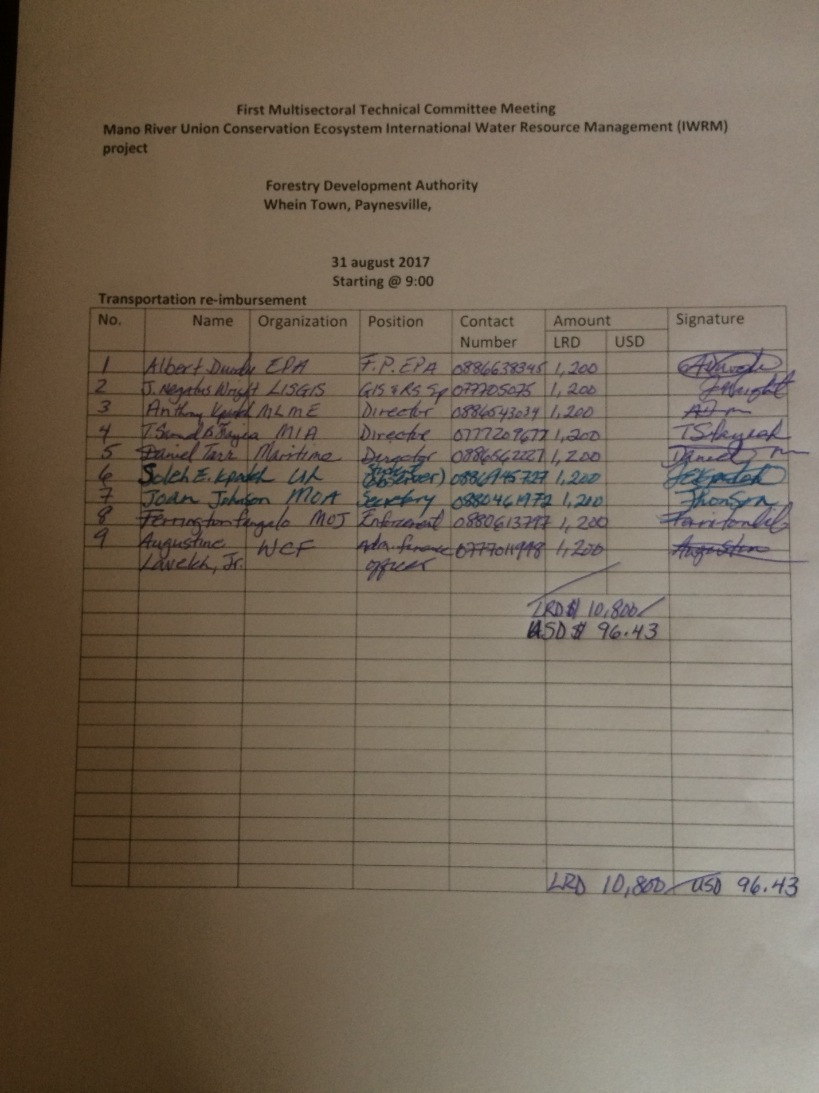

Annex A (Continues)
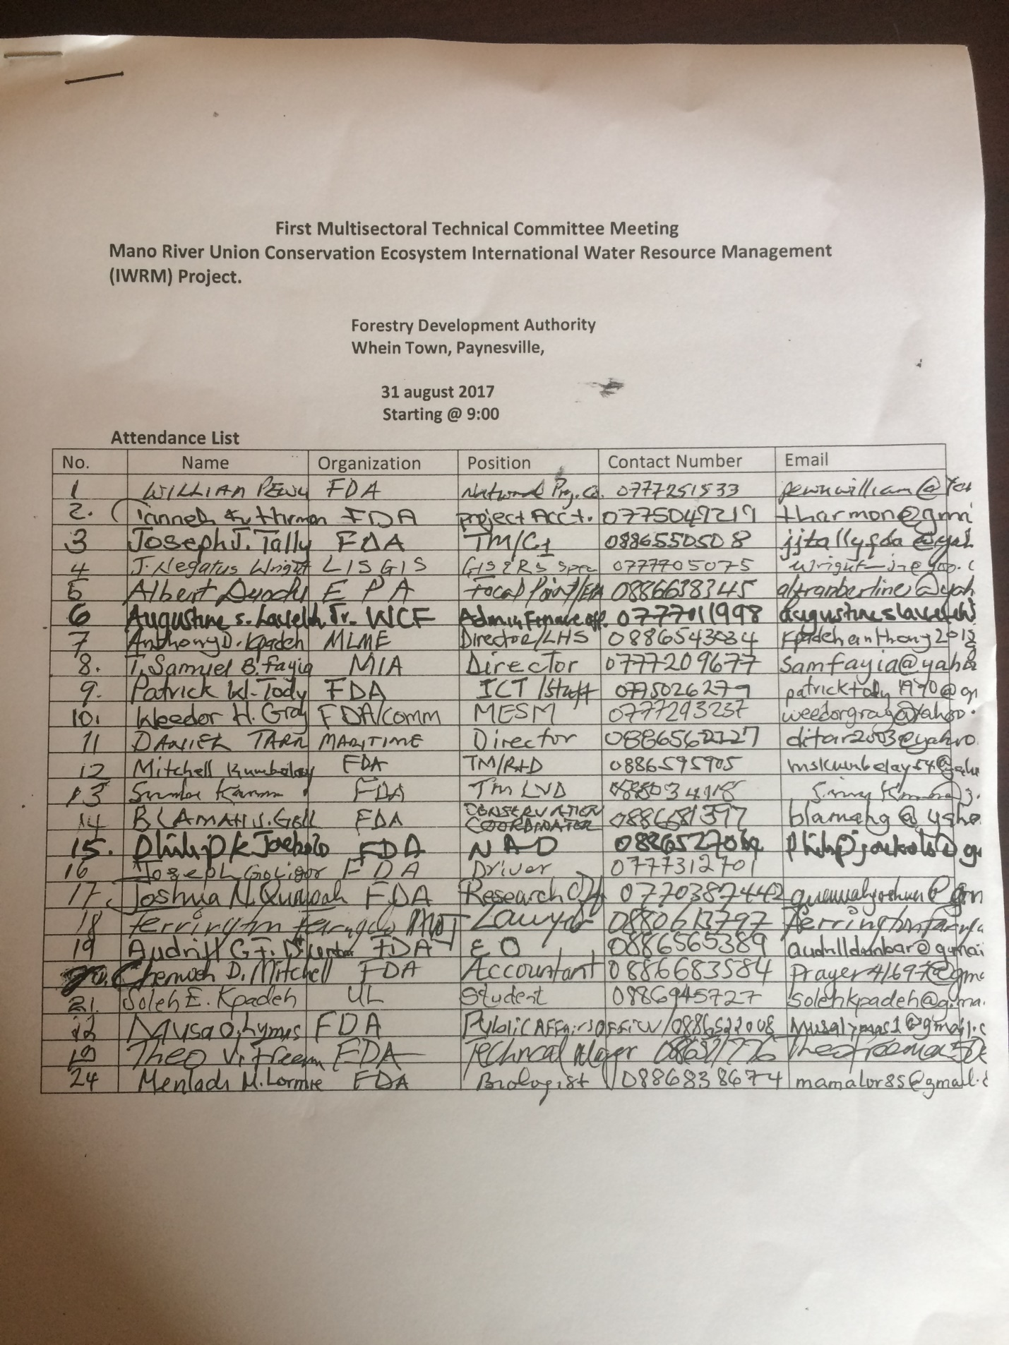
Annex A (Continues)
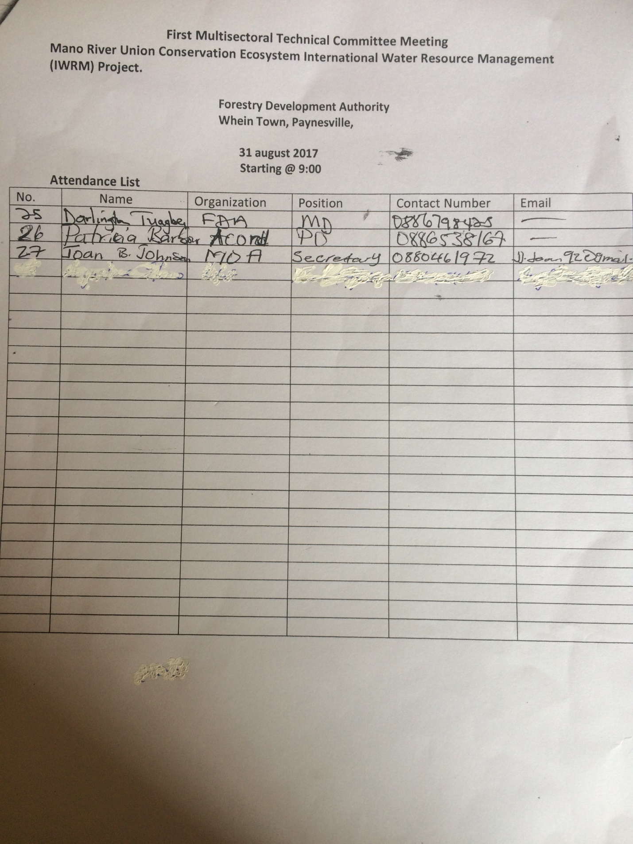
Workshop Pictorial
ANNEX B.: Cross-section of Participants at the first MTC workshop

National Focal Point (Blamah Goll) Makes presentation
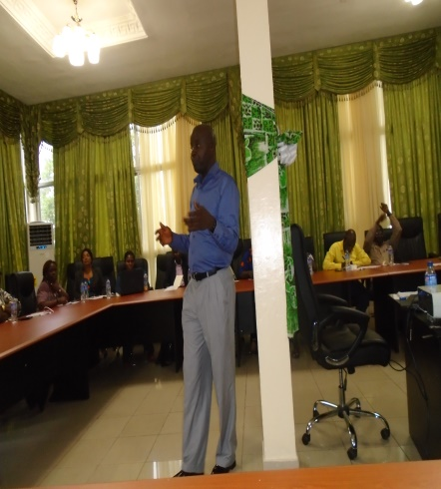

Technical Manager, Commercial Forestry, FDA, gives votes of thanks and closing remarks

ANNEX B (CONTINUES)
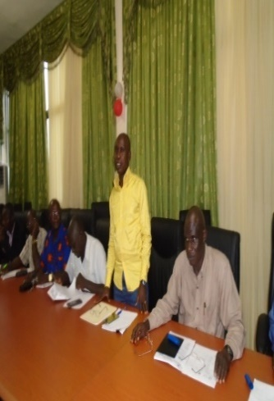

(Annex Cont.)
National Project Coordinator (NPC) takes notes
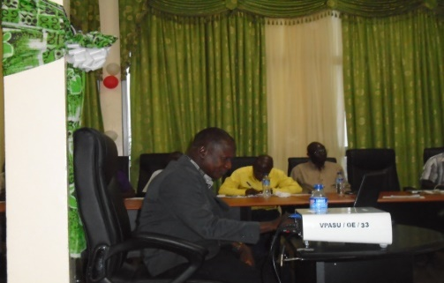

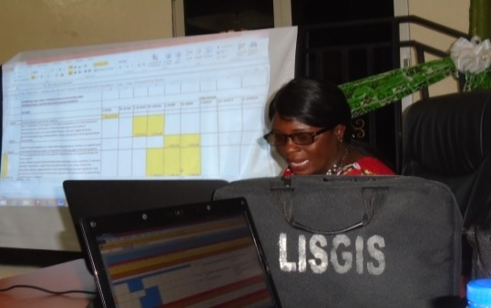

Project Accountant talks about the budget/workplan

