**GEF-IUCN Project - MANO RIVER UNION: LOCAL CONSULTATIVE COMMITTEES AT THE HEART OF FOREST RESTORATION AND TRANSBOUNDARY MANAGEMENT**

Since July 2017, the Mano River Union region covering Côte d'Ivoire, Guinea, Liberia and Sierra Leone has been supported by the International Union for the Conservation of Nature (IUCN) through the Global Environment Facility (GEF) funds for the implementation of the Ecosystem Conservation and International Water Resources Management project. This region is one of the most biologically rich areas in the world, containing a great diversity of mammals) and unique and irreplaceable forest landscapes as well as the sources of the rivers of nearly ten transboundary basins of Africa West. The long-term objective of the project is to provide global environmental benefits through the strengthening of the management of transboundary natural resources for sustained ecological benefits and improved livelihoods for the forest adjacent communities as well as to maintain the intactness of the transboundary ecosystems including the protected areas and their surrounding zones where integrated land and water resource management strategies are implemented.

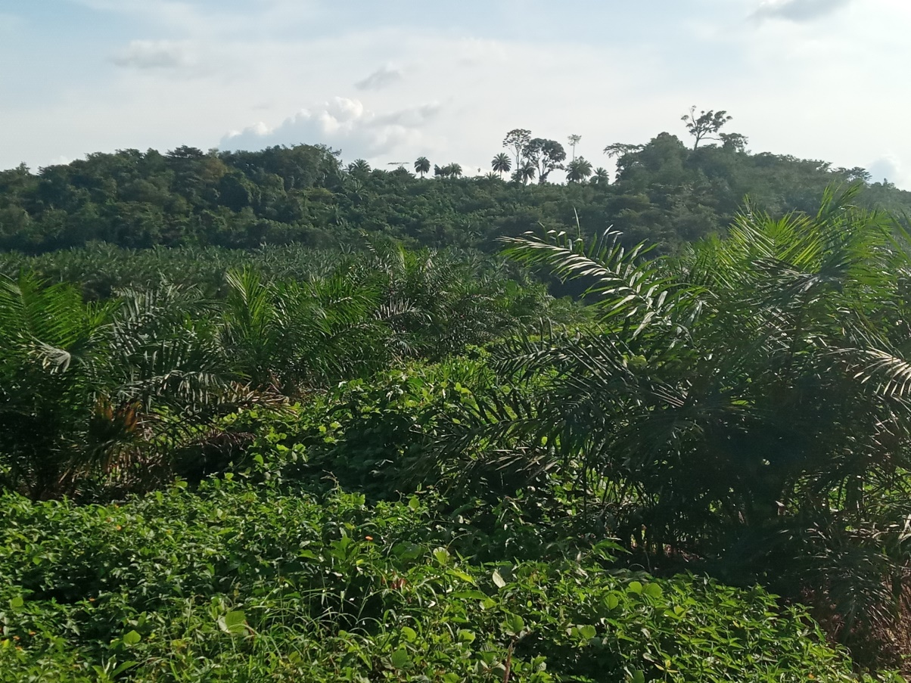

Agroforestry in the Diecke Forest (Guinea) Photo Gnapi Florent Rabe

The launch of the project since 2017 raises hope for this sub-region and beyond, has placed at the heart of its strategy, the mobilization of Stat es and the effective involvement of adjacent communities in the management and conservation of ecosystems. To strengthen governance, and to recognize the principle of legality and legitimacy, the project envisaged as a device the creation of local advisory committees and cross-border committees at each of the four intervention sites. The objective is to strengthen transboundary cooperation and synergies and to ensure the participation of local communities in project activities, especially during the implementation of the Restoration Opportunity Assessment Methodology (ROAM) which promotes the rights and interests of local communities in integrated land planning and the application of landscape restoration options.

The establishment of these various local consultative committees guarantees the success of this project in the various sites. The purpose of information sharing on the project objective and results is to raise awareness of the enormous advantages of the project to members of the riparian communities in a buffer zone of 5 km around the various protected areas. In all the intervention sites, participants from 58 villages were involved in this process. The representatives of the various villages, numbering 136, were democratically chosen by the inhabitants themselves and in the presence of local administrative authorities and customary officers. Women represent a total of 38% of the members of these local consultative committees. A total of seven local committees were established between 2018 and 2019.

On Site 1: The transboundary forest block comprising the Diecke National Forest Protected Area Complex (Guinea), Mount Nimba Strict Nature Reserve (Guinea/Ivory Coast) and East Nimba National Park (Liberia);

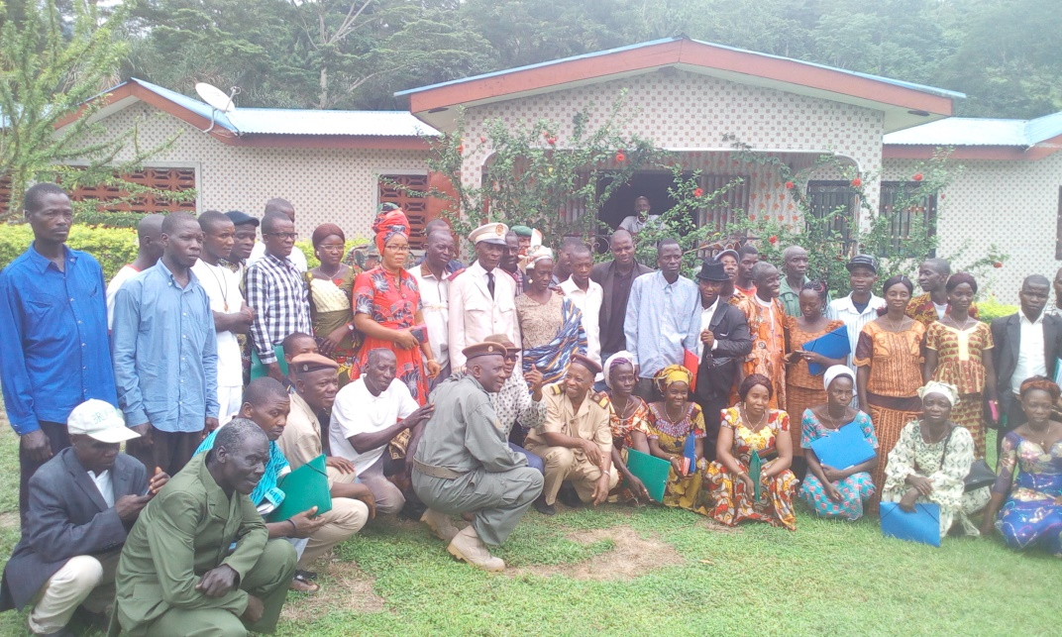

Local consultative committee of Nimba (Guinea). Photo National Executing Agency (NEA) Guinea

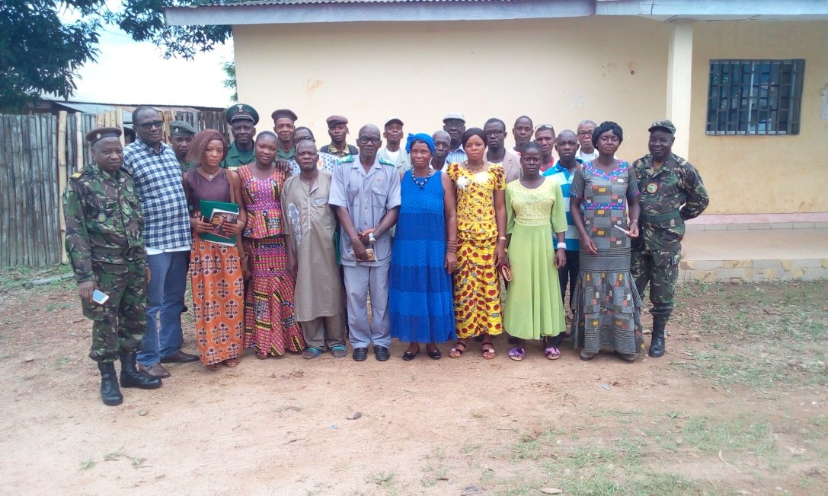

Local consultative committe of Diecke (Guinea). Photo NEA Guinea

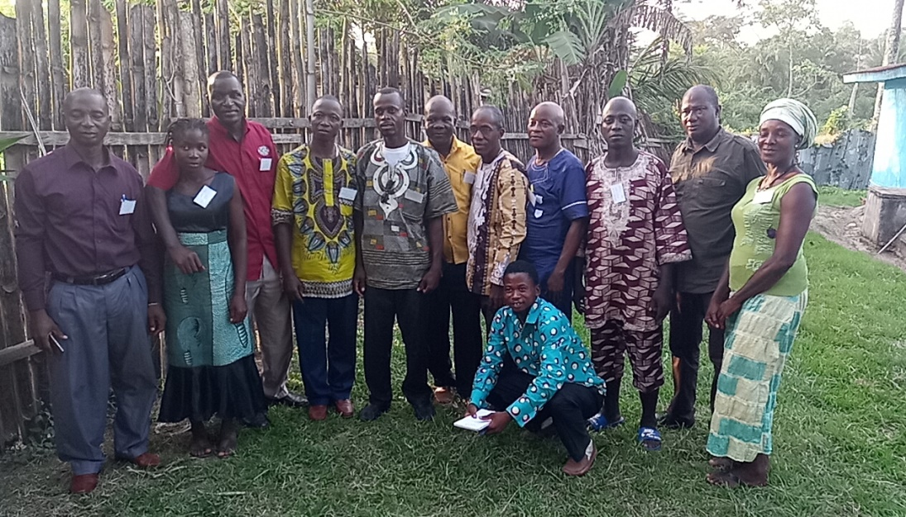

Local consultative committe of Gba Community Forest/West Nimba and East Nimba Natural Reserve. photo Rabe G. Florent

Site 2: The transboundary forest block including the Wonegisi Ziama National Forest Protected Area complex Liberia/Guinea);

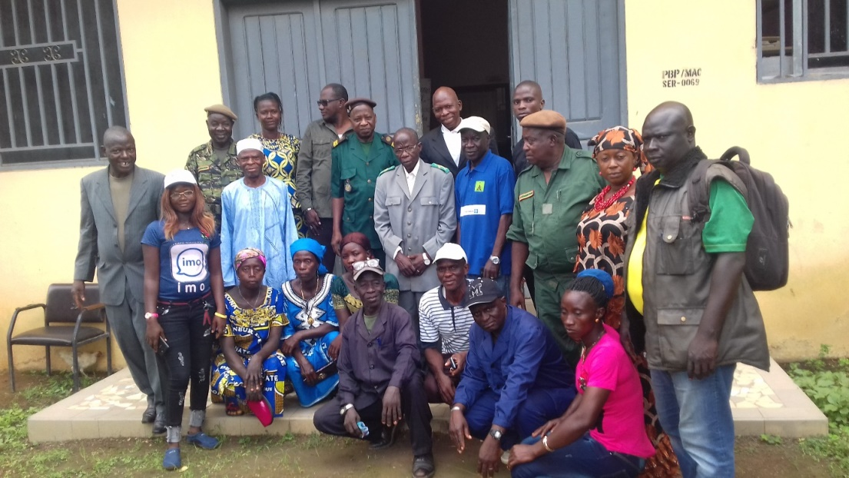

Comité consultatif Llocal de Ziama (Guinée). Photo ANEx Guinée

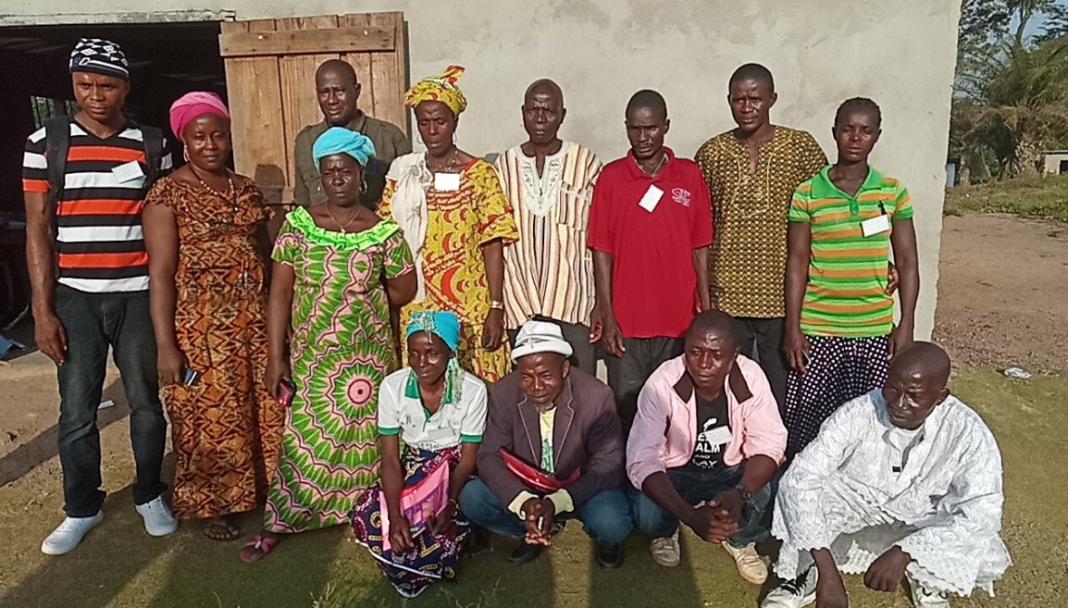

Local consultative committee of Wonegizi protected area (Liberia). photo Rabe G. Florent

Site 3: The transboundary forest block and corridor comprising the Gola Rain Forest National Park Protected Area Complex (Sierra Leone), and the Gola National Forest (Liberia);

**

Local consultative committee of Gola national forest (Liberia). photo NEA Liberia

Site 4: The transboundary forest block and corridor comprising the Sapo National Park Protected Area Complex (Liberia), the Grebo National Forest (Liberia) [and Tai national park (Cote d’Ivoire)].

These committees are of major interest to these riparian communities of the buffer zones, especially as they have the opportunity to measure the increasing pressure exerted on these vital landscapes that contrast with the associated benefits that these ecosystems can provide.

The strong commitment of people living around the landscapes and especially the local consultative committee members and the start of the ROAM process since February 2019 is a turning point for this GEF-funded project implemented by the International Union for Conservation of Nature (IUCN).

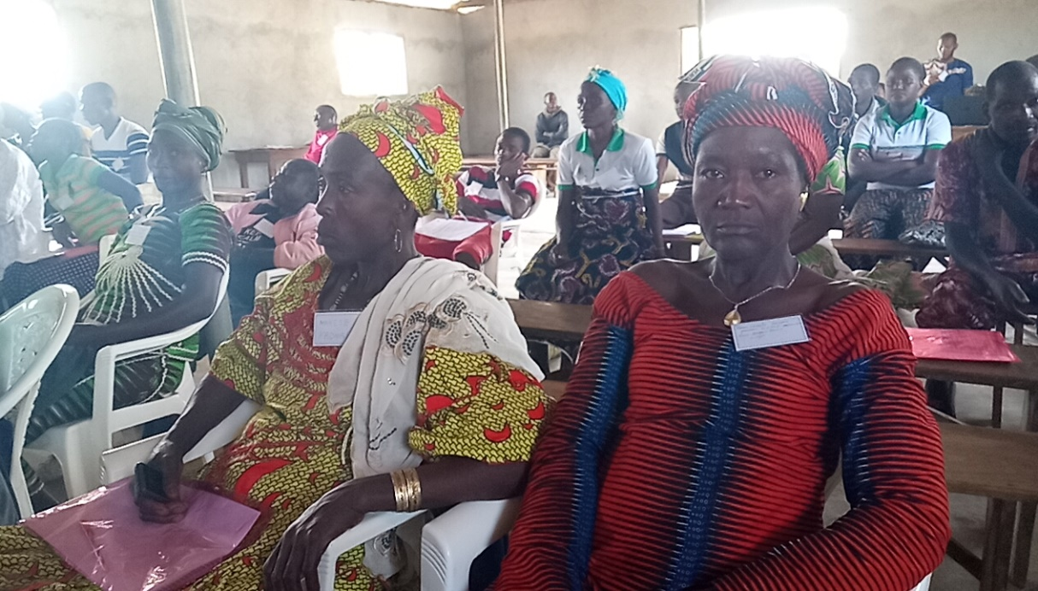

Women in Zorzor District, Liberia, massively participated in the Establishment of the Wonegizi Local consultative Committee. Photo Rabe G. Florent

Project Coordinator: Abdoulaye Doumbia: [adoumbia@mru.int](mailto:adoumbia@mru.int) / [doumbia1959@gmail.com](mailto:doumbia1959@gmail.com) / +232 88 326 262

Communication Specialist: Gnapi Florent Rabe: [frabe@mru.int](mailto:frabe@mru.int) / [gnapiflorent@gmail.com](mailto:gnapiflorent@gmail.com) / +232 75 084 500